3/11/2019

Analysis of the during, before and after the Great recession and it’s impact on US economy

Bala Durga sridevi kesavarapu

**Introduction:**

A recession is a decline or stagnation in economic growth. The Great Recession that occurred in 2008 was devastated world financial markets as well as the banking and real estate industries. The crisis led to increases in home mortgage foreclosures worldwide and caused millions of people to lose their life savings, their jobs and their homes.

In mid-2000s, mortgage lenders seeking to capitalize on rising home prices were less restrictive in terms of the types of borrowers they approved for loans. And as housing prices continued to rise in North America and Western Europe, other financial institutions acquired thousands of these risky mortgages in bulk as an investment, in hopes of a quick profit.

It made catastrophic effect on US economy impact key sectors like employment, housing, banking, stock market etc.

There are many states that are impacted by the great recession. I have taken the most effected states in USA by the great recession. They are Arizona, California, Florida, Michigan, Ohio. These states were hit worst by the recession.

I have taken data from the years 2002-2014 which best explains the overall economic situation how it is impacted during recession and how long it took to recover.

Through Tableau, I have tried to visualize the economic situations of the states of Arizona, California, Florida, Michigan, Ohio in USA before, during and after the recession. I have chosen the following as economic indicators

* GDP
* Unemployment rate
* Home ownership
* Single family housing index
* Stock Market
* Layoffs
* Household income
* Total wages and Salaries

I have created visualizations for all these indicators and created 4 dashboards and a story. The housing dashboard has home ownership and single-family housing price index indicators and a filter to filter the data based on the year.

The Unemployment dashboard has total layoffs and unemployment rate with year as filter.

The GDP and Stock Market dashboard has GDP year over year growth rate and Stock Market rate with state names as filter.

The Wages and Income dashboard has Total wages and salaries of employees and household income with state names as filter. It has a feature where we can hover over a year to see all the values of states related to the hovered year.

**GDP:**

Gross Domestic Product is the total value of everything that is produced within the country. It is measured by Bureau of Economic Analysis quarterly. GDP is calculated by Personal consumption expenditures + government spending + exports- imports. Below is the chart that shows the Year Over Year GDP growth of the 5 states.

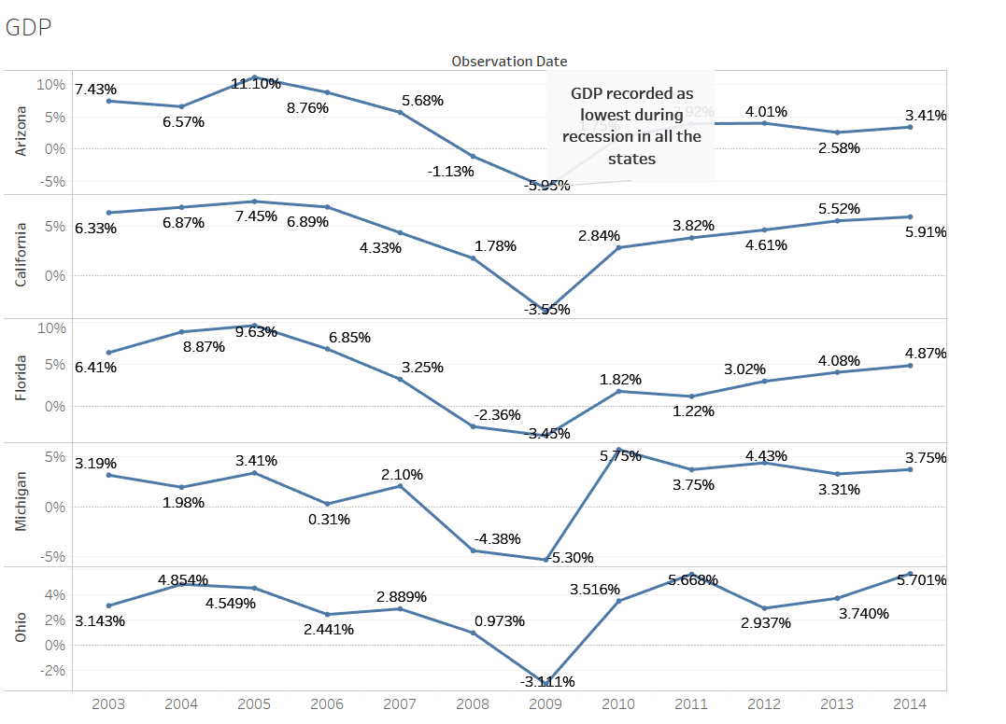

I have placed the observation dates in Columns and the GDP values of the 5 states in Rows. I selected discrete lines chart to represent the YOY growth rate of GDP.

Pre-recession, the GDP growth is fluctuating but in a good position overall. During the recession the growth has declined in 2009 mostly and post-recession it gradually increased.

**Unemployment Rate:**

The unemployment rate is a measure of the prevalence of unemployment. It is calculated by number of unemployed individuals by all individuals currently in the labor force. The below chart represents the unemployment rate for the 5 states.

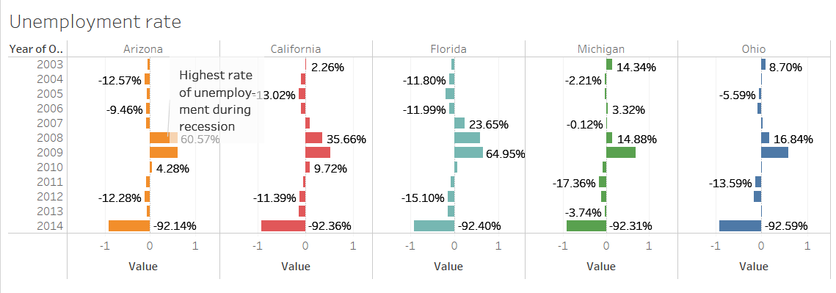

I have placed observation date in rows and the unemployment rate values in columns. I chose horizontal bars chart to represent the unemployment data. The highest unemployment rate is during the recession period which is about 61%. This was due to the mass layoffs. It took 3 years to recover from the unemployment.

**Home ownership:**

Home ownership data represents the people who own a house. The data of home ownership from 2002-2014 has been taken and visualized as below.

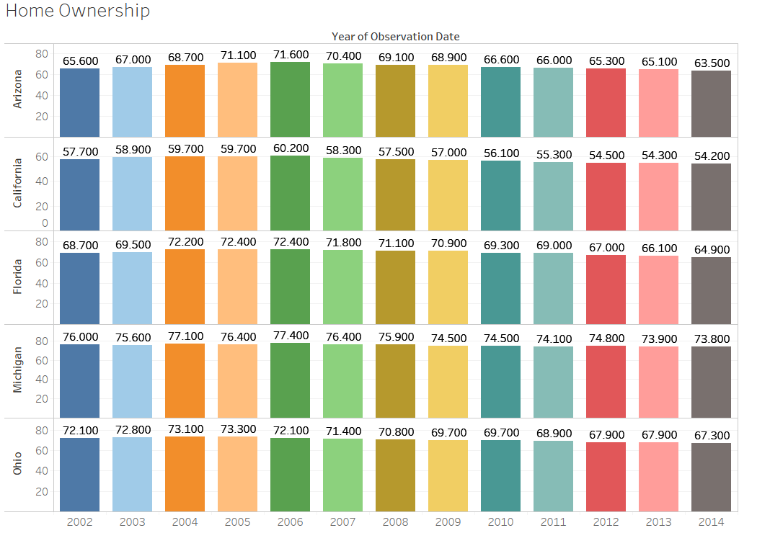

Pre-recession, the home ownership rate is constant, and it decreased during the recession period in 2008-09. But it’s been decreasing ever since the recession.

**Single family housing index:**

House price index is a broad measure of the movement of the prices of single-family houses. It measures average price changes in repeat sales. Below is the chart that represents housing price index of single-family houses.

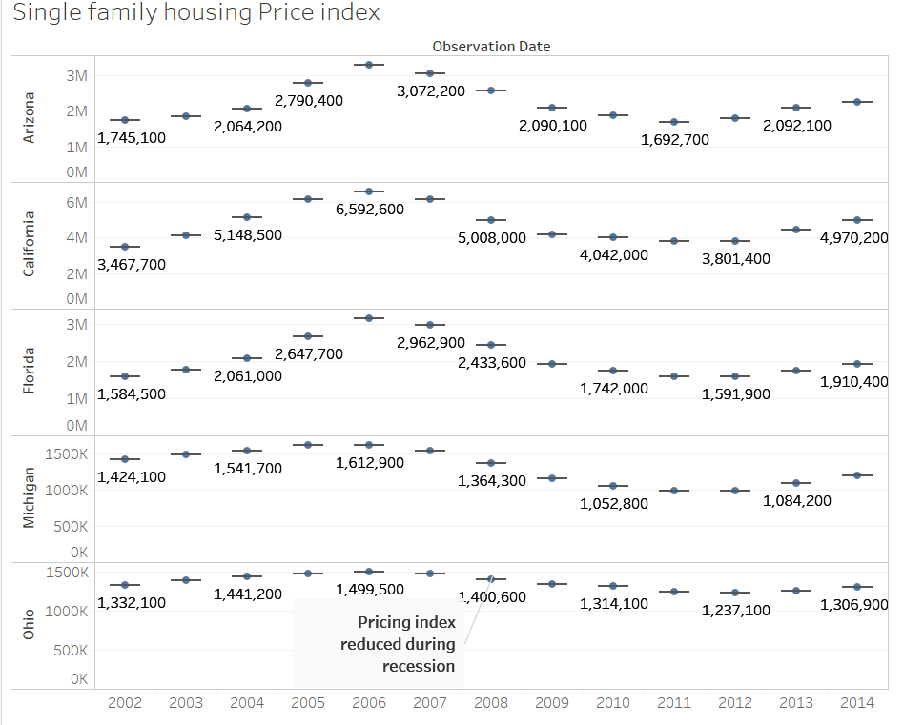

The housing price index increased gradually from 200-2007. During recession it declined drastically from 2008 and the effect continued till 2012. Post-recession the index improved from 2013-14.

**Stock Market:**

Stock Market is the aggregation of buyers, sellers of stocks. Stock Market is one of the sectors that was hit worst due to the recession. Though the stock market trends are fluctuating always, recession had a major impact on stock market. Below is the chart that represent stock market Year Over Year growth rate.

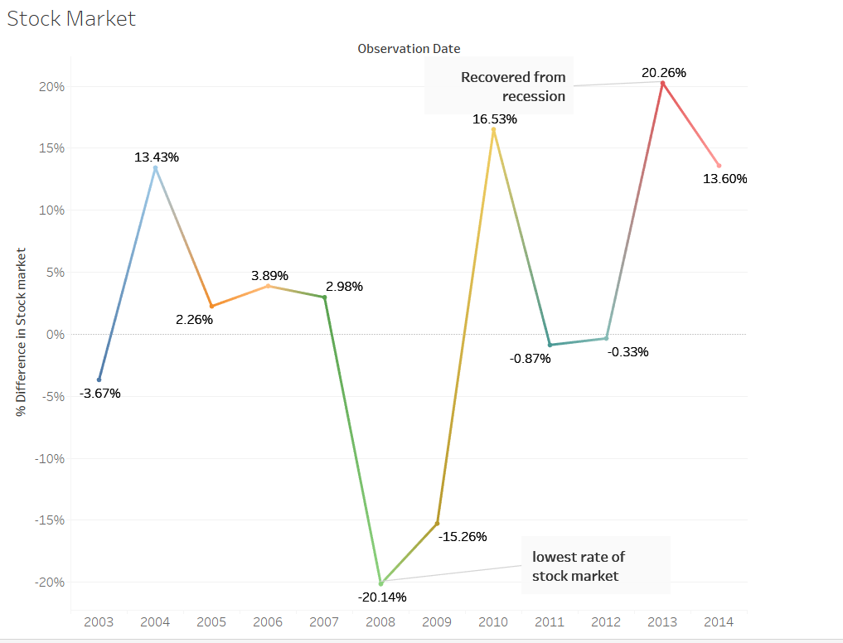

Stock Market rate is not constant always. It is always fluctuating. Pre-recession it declined from 2004-2007 but the has drastically dropped in 2008 but quickly recovered post-recession in 2010. A line graph best represents the data which has fluctuations in it.

**Layoffs:**

A layoff may be temporary suspension or permanent termination of an employee. It is common to have layoffs in private sector but there were mass layoffs during recession period. Below chart represents the total layoffs in 5 states where there are maximum number of employees.

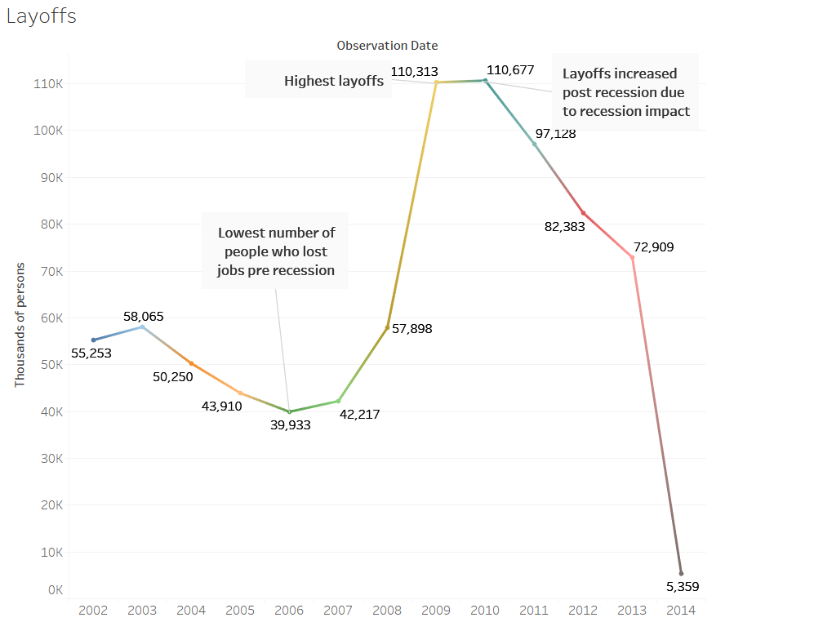

The lowest number of people who lost their jobs is in 2006 pre-recession. The highest layoffs occurred in recession period from 2008-2010. Post-recession the layoffs gradually decreased.

**Household income:**

Household income is an economic measure which is applied to one household or aggregated across a country as a group. It is used as a measure to describe economic status of a household. The picture below represents a chart with median household income of people in the 5 states.

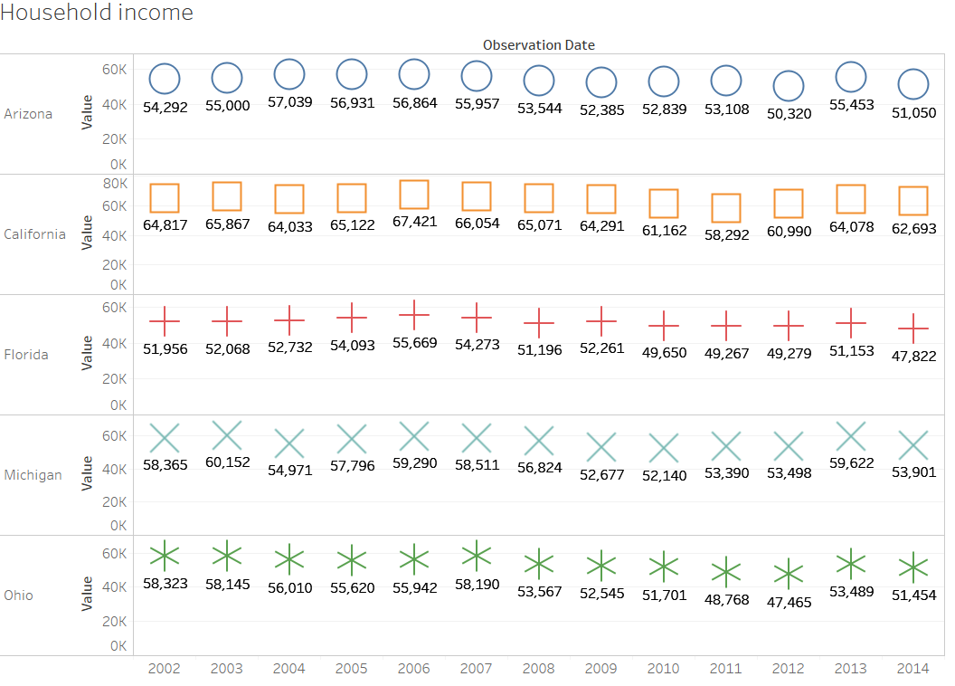

We can observe the changes in a household’s income through different shapes each representing a state. Pre-recession the income was growing from 2002-2006. During recession the income significantly reduced from 2007-2010. Post-recession the income was fluctuating.

**Total wages and Salaries:**

Wages and salaries are another key factor to determine the economic situation. They are used to record gross wages and salaries earned by employees during the accounting period. The below Gantt bar chart visualizes the total wages and salaries of the employees.

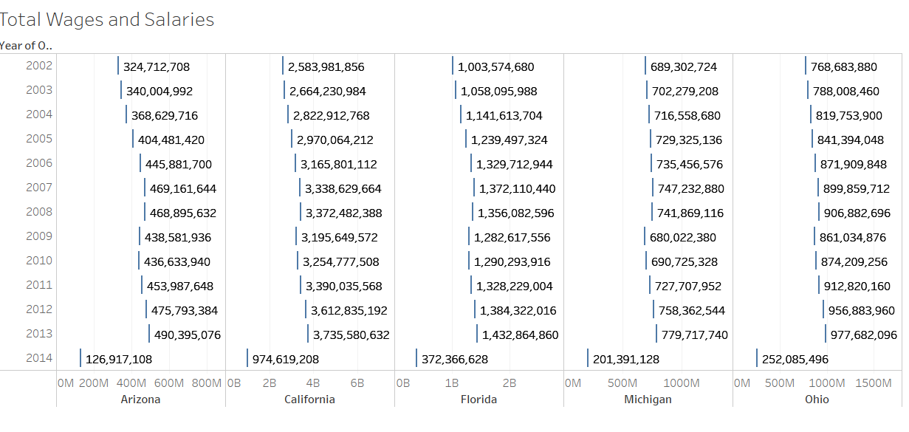

From the chart it is evident that the total wages and salaries are decreased during recession from 2007-08. Post-recession the salaries were decreased significantly and slowly increased after 2011.

**Story:**

I have created a story to describe the economic situation of the most affected states Arizona, California, Florida, Michigan, Ohio of USA by the great recession.

The first story point represents the housing describes that the Home ownership has been in rise from 65% to 71% since 2002 till 2006. But, during recession it dropped to 69% and has been declining ever since the recession.

The second story point represents the unemployment which describes that the employees are most affected due to recession. Unemployment rate increased as high as 65%. There were major layoffs in 2009.Post recession the layoffs decreased and restored to normalcy.

The third story point represents the GDP and Stock Market rate which describes that GDP growth has been very low during recession and has been fluctuating ever since the recession. Stock Markets faced catastrophic losses during recession. Post-recession it again dropped low during 2011-12 and then increased.

The final story point represents the wages and income of the employees which describes that the Total Wages and income of employees decreased during the recession period due to mass layoffs and wages slowly increased post-recession.

**References and data sources:**

* Federal Reserve Economic Data | FRED | St. Louis Fed. (n.d.). Retrieved from <https://fred.stlouisfed.org/>
* Data. (n.d.). Retrieved from <https://www.zillow.com/research/data/>
* U.S. Bureau of Labor Statistics. (n.d.). Retrieved from <https://www.bls.gov/>
* Great Recession Hurt Some States More Than Others. (n.d.). Retrieved from <http://www.thefiscaltimes.com/Articles/2012/06/22/Great-Recession-Hurt-Some-States-More-Than-Others>